SKILL – 01 [OS]
CODES:

#include <stdio.h>
#include <unistd.h>

int main() {
printf("=== PROCESS ABSTRACTION ===\n");

printf("Process ID (PID): %d\n", getpid());
printf("Parent Process ID (PPID): %d\n", getppid());

return 0;
}
=========================================================================
#include <stdio.h>
#include <unistd.h>
#include <sys/types.h>

int main() {

pid_t pid;

printf("Before fork()\n");

pid = fork();

if (pid < 0) {
printf("fork() failed\n");
return 1;
}

if (pid == 0) {
// Child process
printf("\nChild Process\n");
printf("Child PID: %d\n", getpid());
printf("Parent PID: %d\n", getppid());
}
else {
// Parent process
printf("\nParent Process\n");
printf("Parent PID: %d\n", getpid());
printf("Child PID: %d\n", pid);
}

return 0;
}
===================================================================
#include <stdio.h>
#include <unistd.h>
#include <sys/types.h>
#include <sys/wait.h>

int main() {

pid_t pid;

pid = fork();

if (pid < 0) {
printf("fork() failed\n");
return 1;
}

if (pid == 0) {

printf("Child process created.\n");
printf("Child PID: %d\n", getpid());

printf("Executing ls command...\n");

execlp("ls", "ls", "-l", NULL);

// This executes only if exec fails
perror("execlp failed");
}

else {

printf("Parent process.\n");
printf("Parent PID: %d\n", getpid());

wait(NULL);

printf("Child process finished.\n");
}

return 0;
}
==============================================================================
#include <stdio.h>
#include <unistd.h>
#include <sys/types.h>
#include <sys/wait.h>

int main() {

pid_t child1, child2;

printf("Parent PID: %d\n", getpid());

child1 = fork();

if (child1 < 0) {
perror("fork");
return 1;
}

if (child1 == 0) {

printf("Child 1 PID: %d\n", getpid());
printf("Child 1 Parent PID: %d\n", getppid());

sleep(10);

return 0;
}

child2 = fork();

if (child2 < 0) {
perror("fork");
return 1;
}

if (child2 == 0) {

printf("Child 2 PID: %d\n", getpid());
printf("Child 2 Parent PID: %d\n", getppid());

sleep(10);

return 0;
}

printf("Parent created two children.\n");
printf("Child 1 PID: %d\n", child1);
printf("Child 2 PID: %d\n", child2);

wait(NULL);
wait(NULL);

printf("Parent finished.\n");

return 0;
}
==============================================================================================
strace -e trace=execve ./exec_demo
==============================================================================================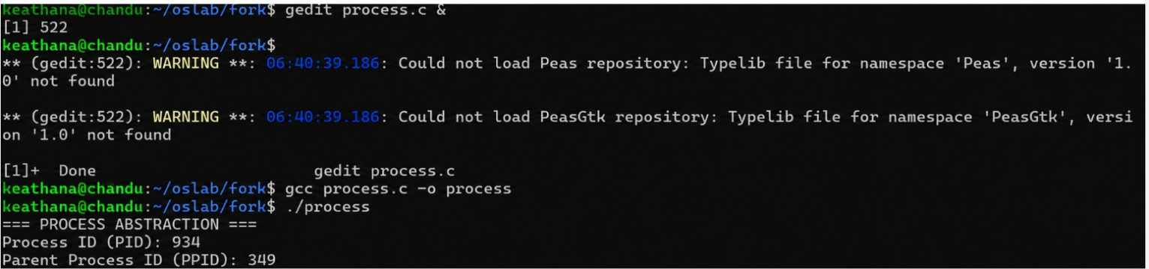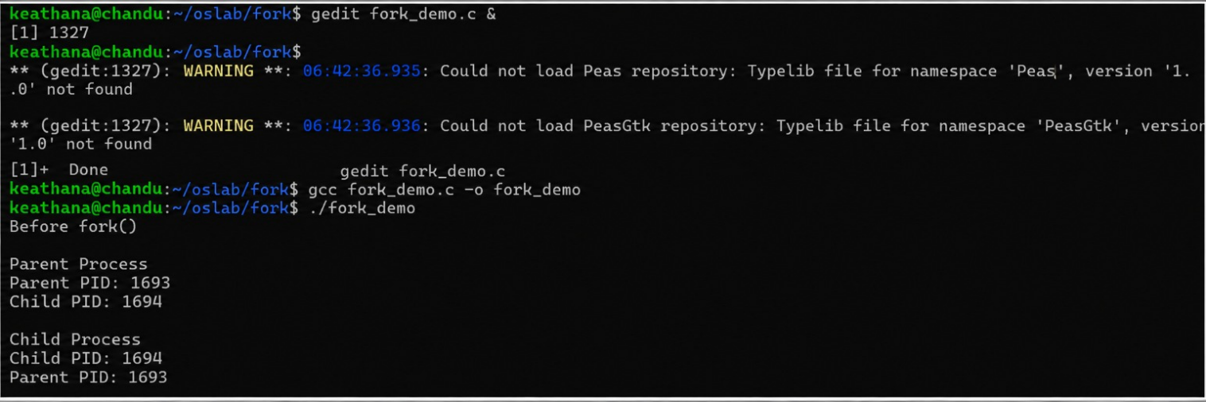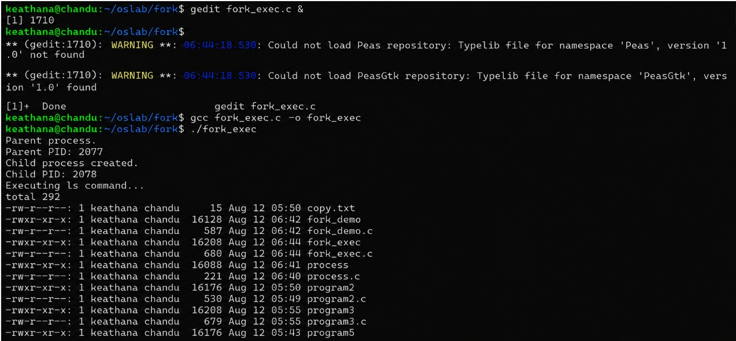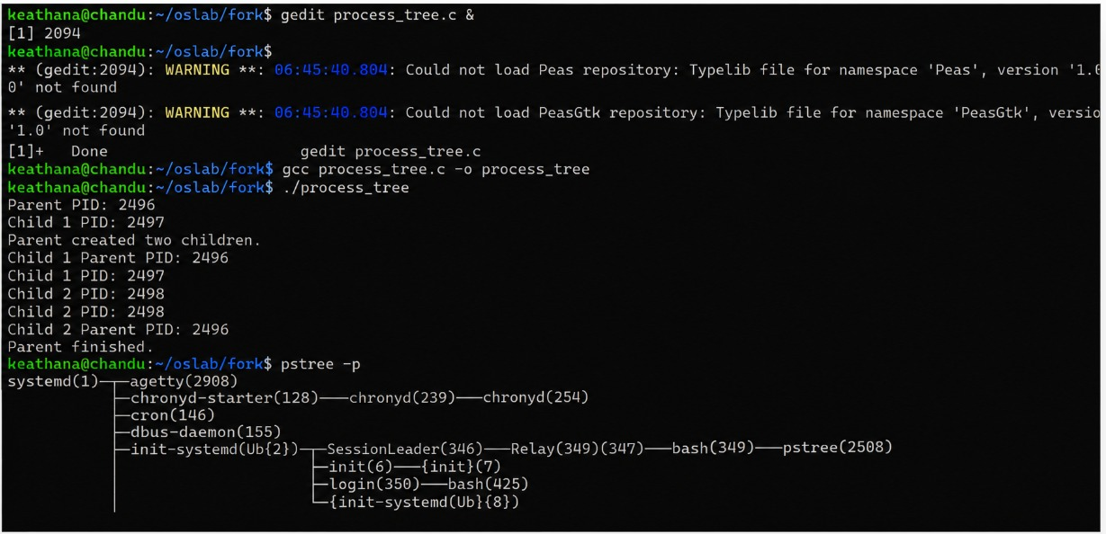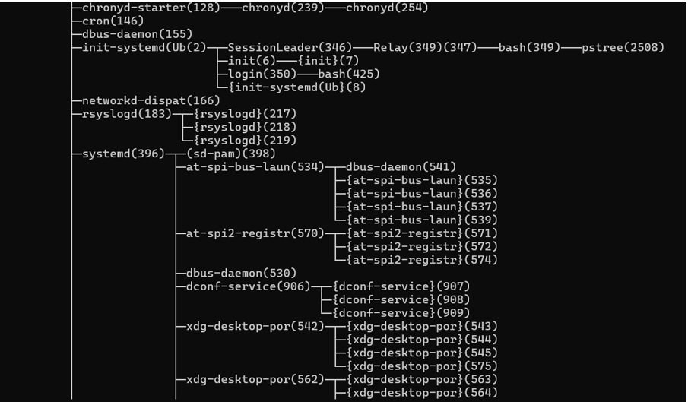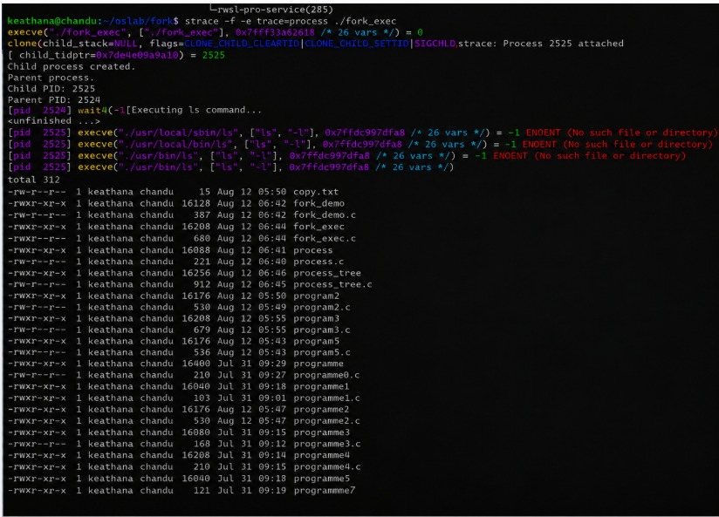
OUTPUT:

